***GIT Assignment Questions***

### **1. Setting Up Git:**

**Q1:** Install Git on your system and configure your name and email using the following commands:

* + git config --global user.name "Your Name"
  + git config --global user.email "[your.email@example.com](mailto:your.email@example.com)"

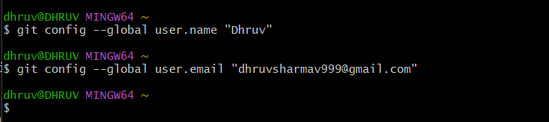

**Q2:** How would you verify that Git has been installed and properly configured? Provide the command and the expected output.

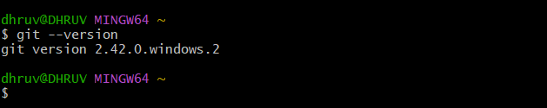

**Q3:** Initialize a new Git repository in an empty directory on your computer using git init.

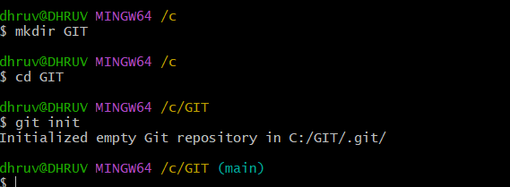

### **2. Basic Git Operations:**

**Q4:** Create a new text file named hello.txt in your repository. Add some content to it. Then, stage the file for commit using the git add command.

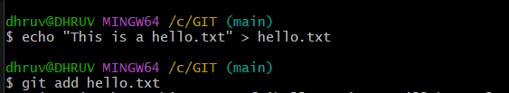

**Q5:** Commit the changes you made to the hello.txt file with a meaningful commit message. Provide the Git command to commit and the expected output.

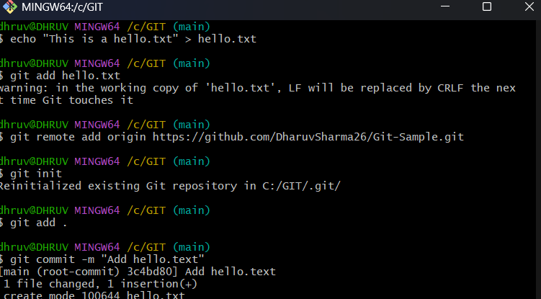

**Q6:** After committing your changes, use the git status command to check the state of your repository. Explain the output.

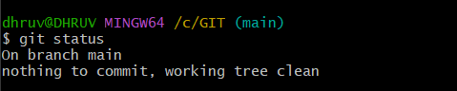

**Q7:** How can you view the commit history of a repository? Use the git log command and describe what information it provides.

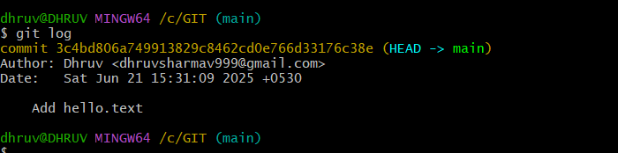

### **3. Branching and Merging:**

**Q8:** What is the purpose of branching in Git? How do branches help in software development?

**Q9:** Create a new branch called feature-branch and switch to it using the appropriate Git command.

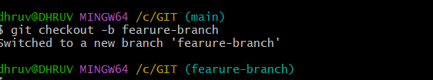

**10:** Create a new file named feature.txt on your new branch and commit the changes. Then, switch back to the main branch.



**Q11:** Merge the feature-branch into the main branch. What command would you use to merge the changes, and what happens if there are no conflicts?

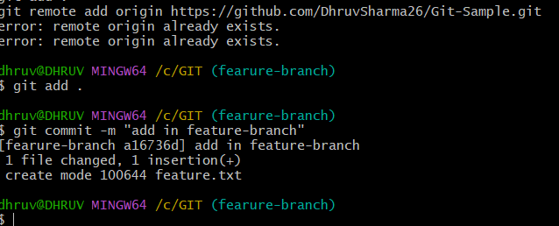

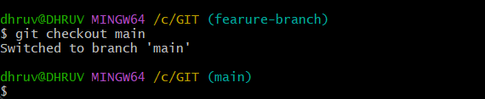

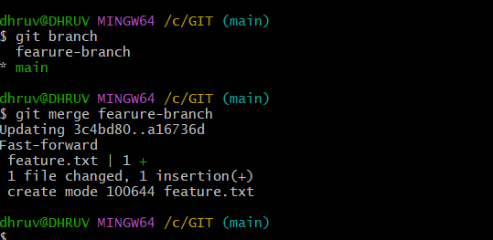

**Q12:** What is a merge conflict? Create a scenario where a merge conflict occurs and explain how you would resolve it.

### **4. Working with Remote Repositories:**

**Q13:** What is a remote repository in Git? How is it different from a local repository?

A remote repository in Git is a version of your project that is hosted on a remote server (like GitHub, GitLab, or Bitbucket) and is accessible over a network (such as the internet or an intranet). It allows multiple developers to collaborate on the same project by sharing and syncing their changes.

A local repository is the version of the project that exists on your own computer. It contains:

* The project files
* The .git directory with metadata and commit history
* Your working directory and staging area

**Q14:** Clone a remote repository from GitHub to your local machine using the git clone command. Provide the URL of a public repository to clone.

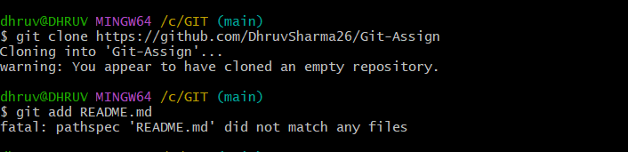

**Q15:** After cloning the repository, make a small change (e.g., edit README.md), and commit the changes to your local repository.

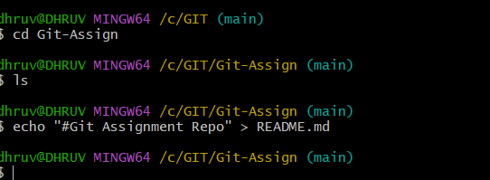

**Q16:** Push your local commits to the remote repository. What Git command is used to push changes to a remote repository? Explain how you would use it.

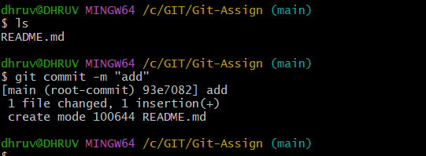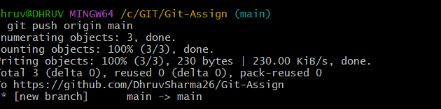

**Q17:** Fetch the latest changes from the remote repository using the git fetch command. What is the difference between git fetch and git pull?

The git fetch command is used to download the latest changes (new branches, commits, updates) from the remote repository into your local repository without merging them into your working branch.

It updates your local copies of the remote branches but leaves your current working branch unchanged.

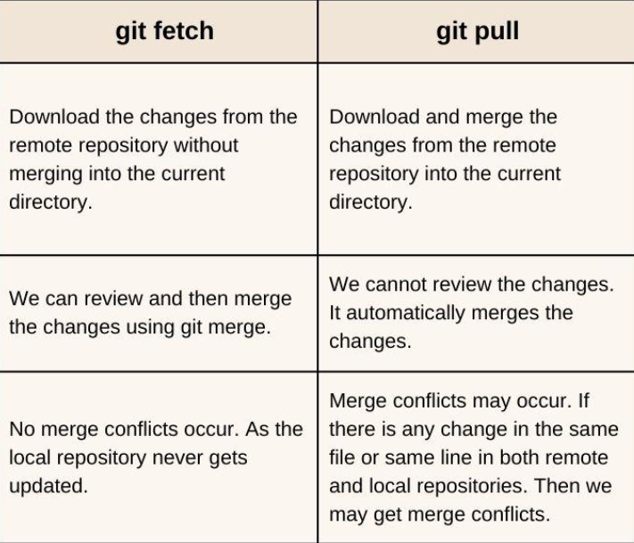

### **5. Undoing Changes in Git:**

**Q18:** After making several commits, you realize that a commit message needs to be changed. How can you edit the last commit message using Git?

Git commit –amend

This command allows you to modify the last commit message and even include new staged changes if needed.

After running this command, your default text editor will open, allowing you to edit the previous commit message.

Once saved and closed, the new commit message replaces the old one.